Pinnacle Dance Payment Policy
Why do we do this?
- To sustain a better level of commitment to classes, ensuring students continue to develop their skills weekly and feel as confident as possible in the run up to shows.
- To maximize lesson times without loosing valuable time at the beginning and end of classes.
How does it work?
- Class fees for the month are due either on or before the first class your child attends of each month.
- You can pay by cash or by BACS (please ask for details). For all payments please reference your name and class fees. Cash payments should be in a sealed envelope. If you pay by BACS please send a text to confirm payment has been made, this must be paid before class to avoid late payment charges.
- A fee reminder will be sent out by text a week before fees are due for the following month.
- Any late fees will incur a £2 admin charge per week and may forfeit your child’s place in that class.
- All classes are payable unless booked off for holiday a month in advance. (Only four weeks per academic year) Once class fees have been paid, refunds cannot be given for missed classes.
- If you decide to try a new subject, you may pay for just that lesson, the rest of the month’s fee for that class will then be due the following week. This applies to new dancers also.
- A months notice must be given if wishing to leave Pinnacle Dance.
Heath and Safety
- Please ensure that correct uniform and footwear is worn for all classes.
- Hair must be tied up, preferably in a bun for Modern Theatre and Contemporary.
- Parents/carers should not wait in the hall whilst classes are in progress. Please only enter to collect your child after the class has finished.
- You must let us know if any contact information provided on your child’s registration form changes.
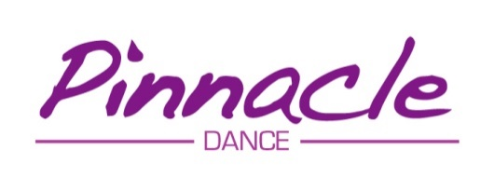
- Students must be picked up from inside the premises and a letter must accompany any other arrangements made by parents/carers.

