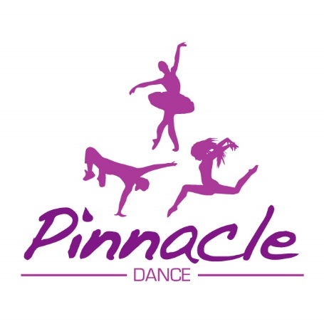

Safe Guarding Policy 2020

Pinnacle Dance School and its volunteers, are committed to ensuring a safe environment for children and young people. We believe it is unacceptable for a child or young person to experience abuse of any kind. We recognise our responsibility to safeguard the welfare of all children and young people, by a commitment to recommend best practice which protects them.

This policy applies to our paid staff, volunteers, students or anyone working on behalf of the dance school.

We recognise that:

- The welfare of the child/young person is paramount.
- All children, regardless of age, disability, gender, racial heritage, religious belief, sexual orientation or identity, have the right to equal protection from all types of harm or abuse.
- Working in partnership with children, young people, their parents, carers and other agencies is essential in promoting young people’s welfare.

The purpose of the policy:
- Provide protection for the children and young people who participate in our show productions, exams or any other activities
- Provide staff and volunteers guidance on procedures they should adopt in the event that they suspect a child or young person may be experiencing, or be at risk of harm

We will seek to safeguard children and young people b
- Value, listen to and respect all students
- Adopt child protection guidelines through procedures and safe working practice for staff and volunteers
- Recruit staff and volunteers safely, ensuring all necessary checks are made
- Share information about child protection and safe working practice with children, parents, staff and volunteers
- Share information about concerns with agencies who need to know, and involve parents and children appropriately.
- Provide effective management for staff and volunteers through supervision, support and training.

This policy will be reviewed each year in line with UK Safe guarding guidance or sooner in light of any changes in legislation or guidance. All changes will be communicated to our members with immediate effect.

All teachers are DBS checked and fully insured.

